2019/2020
Career Life Connections (CLC) Online Access

Hello Grade 11 Students,

You are now good to go for the Career Life Connections (CLC) online course. Here’s how you access the course materials:
- Log on to the school district website
- Go to Student Resources and then scroll down and click on Moodle
- Then click on the brown “Moodle”
- Log in on with your school username and password
- Scroll down to near bottom of page, under WL campus, and click on it.
- Click on Career Life Connections (2 credit) course at top of page.
- Assignments to be completed are listed on the left hand side of the page.
- The back of this page shows you how to click through all of the assignments.
- Note: YOU must submit your work online via Moodle. If there is no submit button then double check to make sure you are completing the correct assignment.
You can do your assignments on word, then download and submit on Moodle.
If you have any questions, contact Ms. Thomson in Career Centre.
Email: cynthia.thomson@sd27.bc.ca
Due: Nov. 29 Due: Jan. 17 Due: April 2
1.2: Who Am I 1.3: Reflection: Know Yourself 2.3: Who Am I Surveys
1.2: How Have I Managed 1.4: Case Study 2.4: Reflection: At My Best
1.2: Making It Happen 2.1: What Did You Learn 2.4: Interviewing a Worker
1.3: Reflection: Empathy 2.1: BC Employment Sector 2.5: Knowing Yourself
1.3: Letter to self 2.2: Safety 2.5: Reflection: What you
1.3: Case Study: Social Skills learned

Due: May 29
2.6: Prepare Your Resume 2.6: Explore Your Pathway 3.2: Transferable Skills
2.6: Cover letter 2.6: Graduation at a Glance

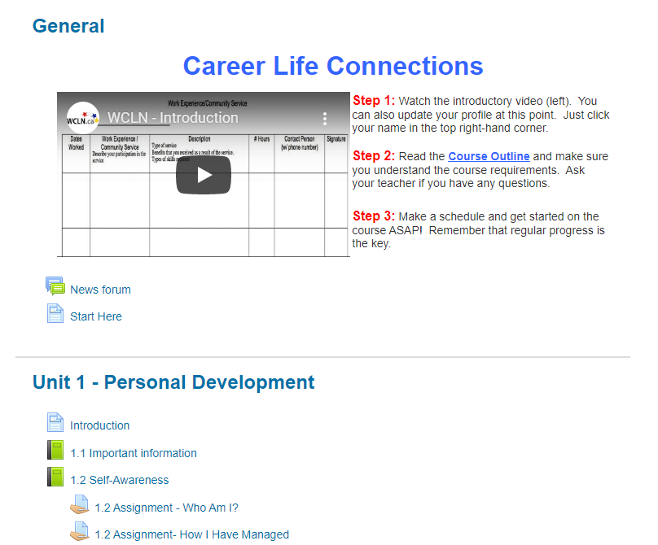

Click for Unit content

Hand in links for assignments upon completion

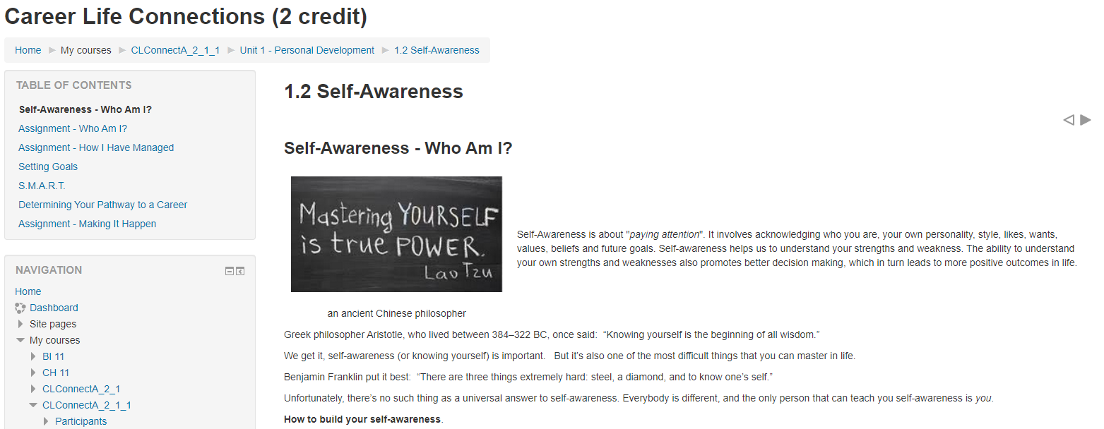
Table of contents to flip through pages
Click on dark arrows to flip through assignment pages

